Types of Vocabulary

1. Based on Use and Knowledge
# Source: AI Source: Provided by: [Data Path: Persons Table -> ID Column: 1, Name_En Column: Motasem Essam] -> From: [Chatgpt (GPT-4-turbo)] on [7/30/2025]
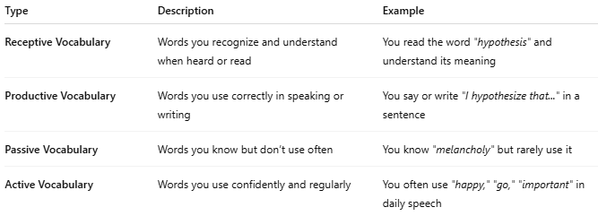
Type | Description | Example
Receptive Vocabulary | Words you recognize and understand when heard or read | You read the word "hypothesis" and understand its meaning
Productive Vocabulary | Words you use correctly in speaking or writing | You say or write "I hypothesize that..." in a sentence
Passive Vocabulary | Words you know but don’t use often | You know "melancholy" but rarely use it
Active Vocabulary | Words you use confidently and regularly | You often use "happy," "go," "important" in daily speech

2. Based on Language Skills
# Source: AI Source: Provided by: [Data Path: Persons Table -> ID Column: 1, Name_En Column: Motasem Essam] -> From: [Chatgpt (GPT-4-turbo)] on [7/30/2025]
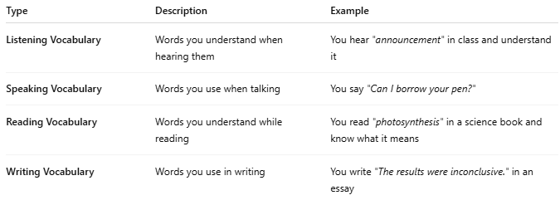

Type | Description | Example
Listening Vocabulary | Words you understand when hearing them | You hear "announcement" in class and understand it
Speaking Vocabulary | Words you use when talking | You say "Can I borrow your pen?"
Reading Vocabulary | Words you understand while reading | You read "photosynthesis" in a science book and know what it means
Writing Vocabulary | Words you use in writing | You write "The results were inconclusive." in an essay

3. Based on Learning Context
# Source: AI Source: Provided by: [Data Path: Persons Table -> ID Column: 1, Name_En Column: Motasem Essam] -> From: [Chatgpt (GPT-4-turbo)] on [7/30/2025]
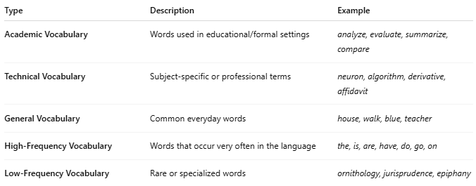

Type | Description | Example
Academic Vocabulary | Words used in educational/formal settings | analyze, evaluate, summarize, compare
Technical Vocabulary | Subject-specific or professional terms | neuron, algorithm, derivative, affidavit
General Vocabulary | Common everyday words | house, walk, blue, teacher
High-Frequency Vocabulary | Words that occur very often in the language | the, is, are, have, do, go, on
Low-Frequency Vocabulary | Rare or specialized words | ornithology, jurisprudence, epiphany

4. Other Classifications
# Source: AI Source: Provided by: [Data Path: Persons Table -> ID Column: 1, Name_En Column: Motasem Essam] -> From: [Chatgpt (GPT-4-turbo)] on [7/30/2025]
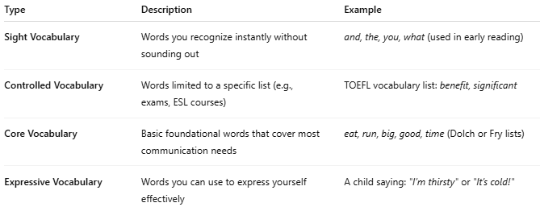

Type | Description | Example
Sight Vocabulary | Words you recognize instantly without sounding out | and, the, you, what (used in early reading)
Controlled Vocabulary | Words limited to a specific list (e.g., exams, ESL courses) | TOEFL vocabulary list: benefit, significant
Core Vocabulary | Basic foundational words that cover most communication needs | eat, run, big, good, time (Dolch or Fry lists)
Expressive Vocabulary | Words you can use to express yourself effectively | A child saying: "I’m thirsty" or "It’s cold!"

📌 Summary Diagram (Text-Based)
# Source: AI Source: Provided by: [Data Path: Persons Table -> ID Column: 1, Name_En Column: Motasem Essam] -> From: [Chatgpt (GPT-4-turbo)] on [7/30/2025]
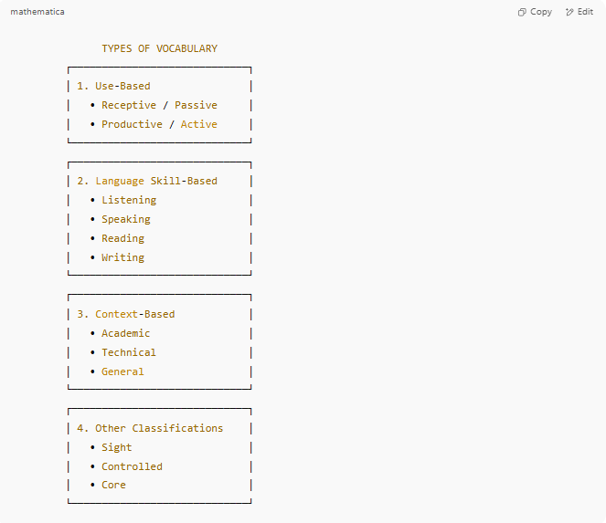
TYPES OF VOCABULARY
┌─────────────────────────────┐
│ 1. Use-Based │
│ • Receptive / Passive │
│ • Productive / Active │
└─────────────────────────────┘
┌─────────────────────────────┐
│ 2. Language Skill-Based │
│ • Listening │
│ • Speaking │
│ • Reading │
│ • Writing │
└─────────────────────────────┘
┌─────────────────────────────┐
│ 3. Context-Based │
│ • Academic │
│ • Technical │
│ • General │
└─────────────────────────────┘
┌─────────────────────────────┐
│ 4. Other Classifications │
│ • Sight │
│ • Controlled │
│ • Core │
└─────────────────────────────┘

